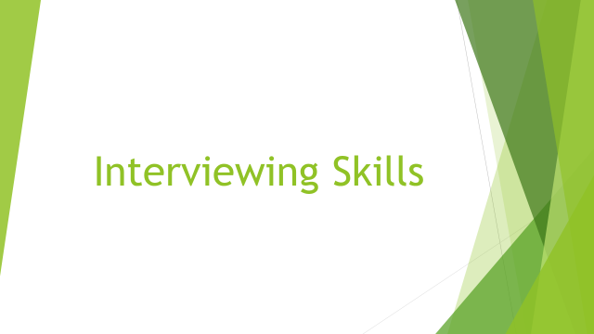

Activity book

Doctoral Training Session

15 June 2016

Ursula Stickler

Department of Languages
FELS

A short (60 minute) session to start thinking about interviews and practise some interviewing skills.

Types of interviews:
- Structured interview
- Semi-structured interview
- Ethnographic interview
- Open interview
- Unstructured interview

Types | Details | Example
Structured | similar to questionnaire, with detailed questions in fixed order | census data collection
Semi-structured | some (most) questions prepared but no fixed order, opportunities to elaborate or slightly deviate from plan | language advising,  most education social / science research
Ethnographic | similar to semi-structured: general area / question field prepared, some questions prepared, flexible | finding out about the shape of hay rakes in rural Styria
Open / unstructured | no prepared questions but a common interest or purpose established | counselling, brainstorming

Activity 1

- Note down which types of interviews you have experience with:

The interview

What do you need for an interview?
- interviewer
- interviewee
- question
- meeting / communication

What is the minimal interview?

1 question 2 people 3 minutes

Activity 2: The minimal interview

- Task:
  - Conduct a quick interview with one other person
  - You will be given one question
  - Then take turns
- Follow up:
  - Conduct a quick interview with one other person
  - You will be given a new question

Interviewing Skills
What skills do you need for interviewing?

Activity 3

- Note down skills you have that make you a good interviewer:
Skills

- Then identify and note down a few facts that stop you from conducting a good interview

Active listening

One of the techniques used to encourage the sharing and disclosing of information is active listening, a person-centred counselling skill.

To listen actively, you need to make your interview partner aware that you are concentrating on them, that you understand what they are saying and that it is important for you.

To project your active listening you can use your body, your posture, your face, your voice, your words, etc.

Activity 4: Practising active listening

You will work in threes: one interviewer, one interviewee, one observer.

As interviewer, use the questions from before, or one of the following:
  - What is your first memory of England?
  - What musical instrument has the most emotionally moving quality for you?
  - When have you ever felt really accepted and appreciated?
  - What weather would you like to have for Christmas?

Use the following page to take notes.

Notes page

- Body language
- Facial expressions
- Subverbal reconfirmations
- Verbal encouragement
- Specific techniques
  - Mirroring
  - Reflecting
  - Paraphrasing
  - Clarifying
- Other:

As observer, take notes of these aspects:

Activity 5: “Recording” your interview

Think about the options you have for recording the content of your interview.

If you have the time, you can practise the activity.
In threes (one interviewer, one interviewee, one observer) try out different ways of recording your interview:
A: take written notes during speaking
B: use a digital device to record
C: try to remember important points and write notes after the interview

Discuss the advantages and disadvantages of the three methods in your group of three.

Write down some thoughts on the following questions:
- Will you be using interviews in your research? Why? / Why not?
- What are the advantages of interviews over questionnaires?
- How do you feel as an interviewer?
- How did it feel to be interviewed?
- What additional skills will you need (or develop further) to conduct interviews?
- How can you practise interviewing further?

